Card Transaction Dispute Management

Overview
Quite often Card transactions are disputed by the Customer. We need to have a mechanism to manage the life cycle of a Disputed transaction from the time a dispute is raised, till it is logically closed.

Disputes can be raised by the customer in several ways. Some of these could be
- Call the Support Center to report a Dispute
- Dispute a transaction from the Mobile or Web interface
- By clicking a Call for Action Button / Link in a Notification

Disputes can be raised for any card transaction, irrespective of whether the card is a Prepaid, Credit or a Debit Card.

Dispute Management solution in Tachyon caters to handling Disputes for all the types of cards in a generic way.

This document attempts to outline a design solution to handle Dispute life cycle.

Deployment Context

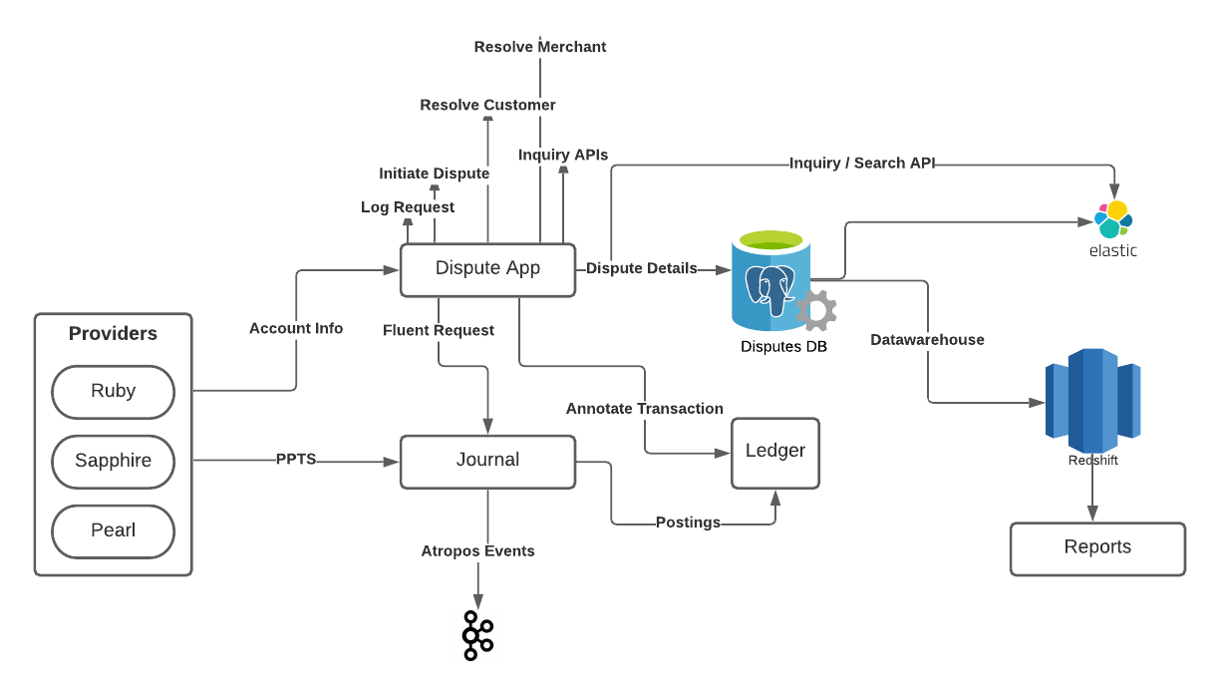
A Disputes App is envisaged for this. As depicted in the context diagram above, the entire life cycle is managed by this Application. Disputes App would expose a comprehensive set of API endpoints to cater to handle different aspects of a Disputed transaction.

There are certain stages in the life cycle that would require the Disputes App to interact with the Accounting system. In such cases, the Disputes App would call the Journal Fluent API.

The Account Provider would intervene in the transaction by providing a PPTS.
The Disputes App will have a storage of its own that will store the details of the Dispute along with the state changes that happen. This storage is used to serve the various Inquiry APIs offered by the App. It interacts with Journal for any Financial Updates.

Dispute Life Cycle
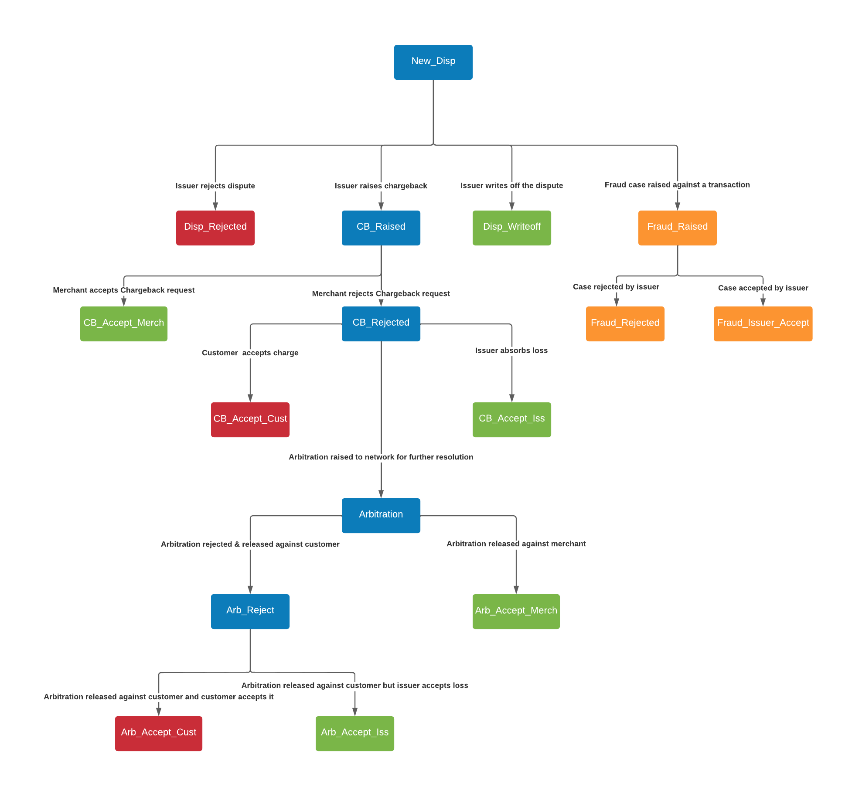
Above chart gives a general overview of how a Dispute is managed. The life cycle may be summarized as below.

- Typically, when a Dispute is reported by the customer, a New Dispute is recorded and the Bank initiates an investigation.
- Based on the outcome of this investigation, the Bank can
  - Reject the Dispute
  - Initiate a Dispute with the Card Scheme who in turn interacts with the Acquirer who may debit the Merchant’s account.
  - Initiate a fraud request in the system if the dispute was raised for a transaction being claimed as fraudulent by the customer.
  - Absorb the disputed amount as an expense by writing it off. This can happen typically when the disputed amount is very small and the cost of chargeback and arbitration process involved is higher than the disputed amount itself.
- Once the dispute is initiated, the Merchant may Accept of Reject this Dispute
- If the Merchant accepts the Dispute, the same is recorded by the Disputes app and the appropriate Financial adjustments are posted.
- In the Merchant Rejects the Dispute, the Customer either Accepts or rejects the outcome. It is possible that the Issuer may absorb the cost instead of pursuing the case further.
- The Issuer may trigger a Re Dispute / Arbitration with the Scheme if the Customer Rejects the outcome of the first iteration.
- The outcome of this step will be final.
  - Merchant Accepts Cost
  - Customer Accepts Cost
  - Issuer Absorbs Cost
- For Fraud related disputes, there are only two outcomes possible.
  - Fraud request is rejected after due diligence from the FRM team of the issuer. Dispute is ruled against the customer in this case.
  - Fraud request is accepted by the issuer after verifying. This indicates that the dispute is ruled in favor of the customer. In this case, the issuer holds the liability to compensate for the amount decided as part of the dispute resolution.
Based on the requirement, the proposed state transitions are shown in the chart below.
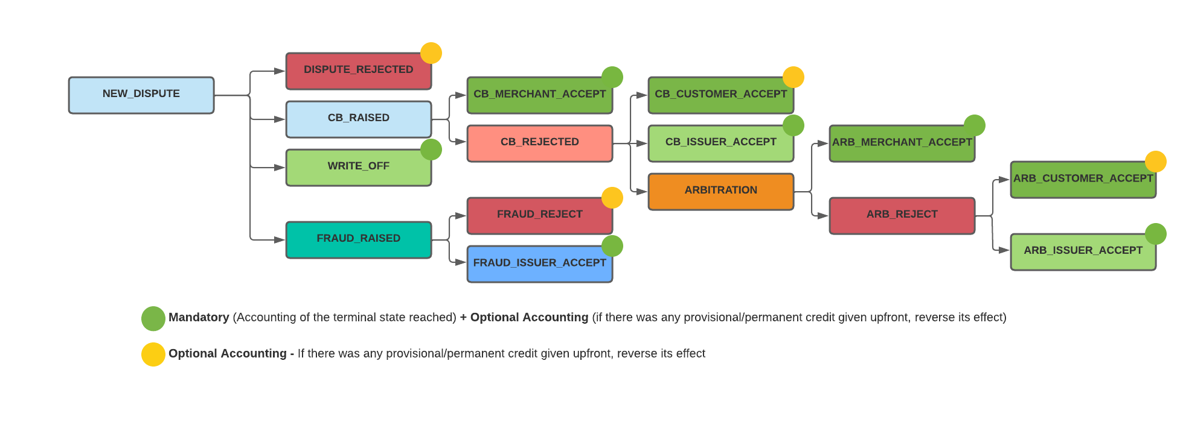

States with yellow and green dots have accounting impact and the corresponding API would interact with Journal for the same. The scenario of optional accounting will come into picture due to the feature of Provisional Credit / Upfront Permanent Credit that the issuer might decide to give to the customer for the dispute raised. Below is the system behavior for this feature.

Upfront Provisional/Permanent Credit:
- A Provisional / Permanent Credit can be provided to the customer account at any time during the lifecycle of the dispute before it hits any terminal state. This can be done only once in the lifecycle of a dispute.
- For certain disputes, the issuer might decide not to provide any provisional / permanent credit at all.
- In case a provisional credit is provided to the customer, the system is expected to credit the Account Holder ledger with an amount that may be equal to or lesser than the disputed amount, as chosen by the Operations executive of the bank. However, the customer will not be able to withdraw/use this credit amount from the account.
- If a permanent credit is provided to the customer, the system is expected to credit the Account Holder ledger with an amount that may be equal to or lesser than the disputed amount, as chosen by the Operations executive of the bank. Since this is a permanent credit, the customer will be able to fully use this amount for any transactional purpose.
- Whenever the dispute hits a terminal state, the Provisional / Permanent Credit (if provided earlier) has to be reversed first, and then the actual accounting specific to that state will be carried out. If there was no credit provided earlier, then there is no reversal required. Hence the “optional” accounting part in the above picture.

Solution Approach

DB Design

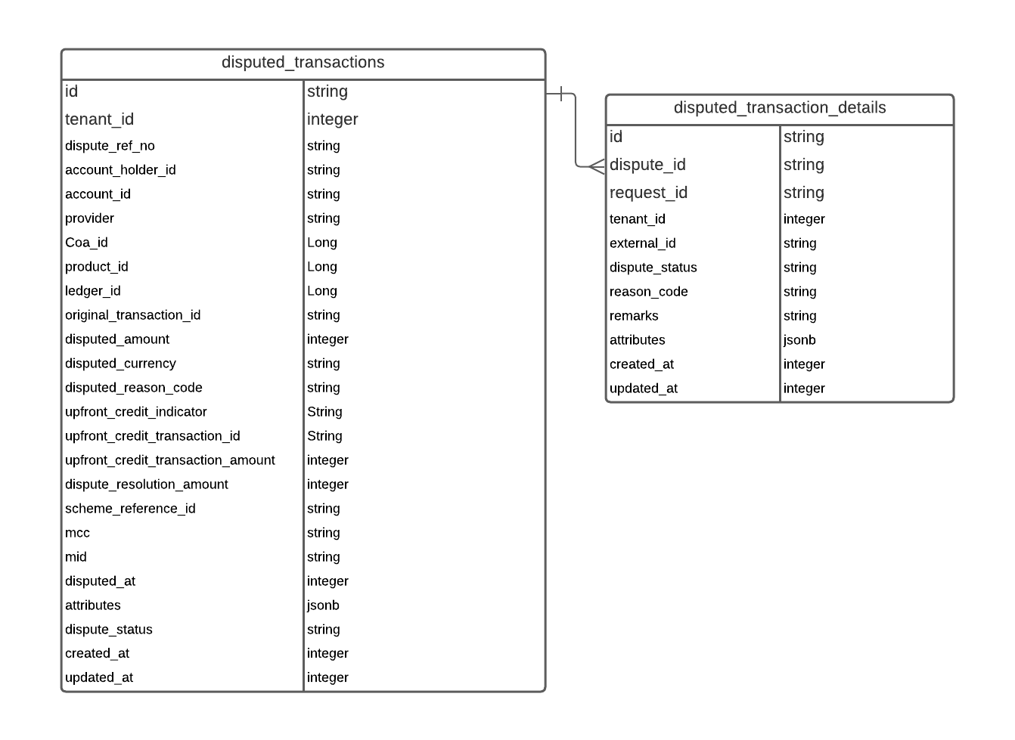

The Disputes App primarily has these two tables
- disputed_transactions
- Disputed_transaction_details

Disputed_transactions has the main record, while the other table has one record per each transition. When a new dispute is created the main record and a record in the details table are created.

Any subsequent transition will create a new record in the details table and update the main record for updated_at, dispute_status. Thus, the latest status and the status date are available in the main table, while the history of state transitions is available in the details table.

- Disputed_transactions
  - PK - id
  - Indexes -
    - Tenant_id, account_id
    - Tenant_id, original_transaction_id,
    - Tenant_id, disputed_at
    - Tenant_id, dispute_status
    - Unique Index -
      - Tenant_id, account_id, original_transaction_id
- Disputed_transaction_details
  - PK - id
  - FK - dispute_id (this is however not defined in the DB)
  - Indexes -
    - Tenant_id, dispute_id
dispute_transaction_detais.request_id may be used as the transaction_id while invoking journal
API.

For any transactions created during the various state transitions (eg: Initiate a New Dispute, Merchant Acceptance of Dispute etc), the attributes column of the disputed_transaction_details table will be updated with the relevant transaction id. This will be useful for linking a disputed transaction to the corresponding internal transactions created at various states of the dispute.

Whenever a provisional or permanent credit is provided to the customer for a dispute, it needs to be captured in the disputed_transactions table. For this purpose, below columns will be added in the table namely,
- upfront_credit_indicator (possible values being PERMANENT, PROVISIONAL,NONE)
- upfront_credit_transaction_id
- Upfront_credit_transaction_amount
- dispute_resolution_amount

API Details

API Listing

Sr# | Method | URL
1 | POST | /disputes/tenants/{tenantId}/accounts/{accountId}/disputes
2 | POST | /disputes/tenants/{tenantId}/accounts/{accountId}/disputes/provide-upfront-credit
3 | POST | /disputes/tenants/{tenantId}/accounts/{accountId}/disputes/raise-fraud
4 | POST | /disputes/tenants/{tenantId}/accounts/{accountId}/disputes/reject-fraud
5 | POST | /disputes/tenants/{tenantId}/accounts/{accountId}/disputes/issuer-accept-fraud
6 | POST | /disputes/tenants/{tenantId}/accounts/{accountId}/disputes/{disputeId}/write-off-dispute
7 | POST | /disputes/tenants/{tenantId}/accounts/{accountId}/disputes/{disputeId}/reject-dispute
8 | POST | /disputes/tenants/{tenantId}/accounts/{accountId}/disputes/{disputeId}/initiate-dispute
9 | POST | /disputes/tenants/{tenantId}/accounts/{accountId}/disputes/{disputeId}/cb-reject
10 | POST | /disputes/tenants/{tenantId}/accounts/{accountId}/disputes/{disputeId}/cb-accept-merchant
11 | POST | /disputes/tenants/{tenantId}/accounts/{accountId}/disputes/{disputeId}/cb-accept-customer
12 | POST | /disputes/tenants/{tenantId}/accounts/{accountId}/disputes/{disputeId}/cb-accept-issuer
13 | POST | /disputes/tenants/{tenantId}/accounts/{accountId}/disputes/{disputeId}/reinitiate-dispute
14 | POST | /disputes/tenants/{tenantId}/accounts/{accountId}/disputes/{disputeId}/arb-accept-merchant
15 | POST | /disputes/tenants/{tenantId}/accounts/{accountId}/disputes/{disputeId}/arb-reject
16 | POST | /disputes/tenants/{tenantId}/accounts/{accountId}/disputes/{disputeId}/arb-accept-customer
17 | POST | /disputes/tenants/{tenantId}/accounts/{accountId}/disputes/{disputeId}/arb-accept-issuer
 | GET | /disputes/tenants/{tenantId}/disputes/{disputeId}
 | GET | /disputes/tenants/{tenantId}/disputes? … Various query Params
 | GET | /ruby/tenants/{tenantId}/accounts/{accountId}

Disputes App will have a notion of Providers for whom disputes are managed by the Disputes App.

Disputes App APIs are structured around the AccountId, Transaction Id and the Dispute Id.
However, Disputes App may need additional information such as CoAId and Product Id to interact with the other downstream applications like Aura. In order to facilitate this, the initial Dispute Creation API would interrogate the Provider to fetch certain Account related information and persist it as part of the Dispute data. This will be used by the Disputes App for all its interactions with the other downstream systems. A representative flow of the interaction is shown below.

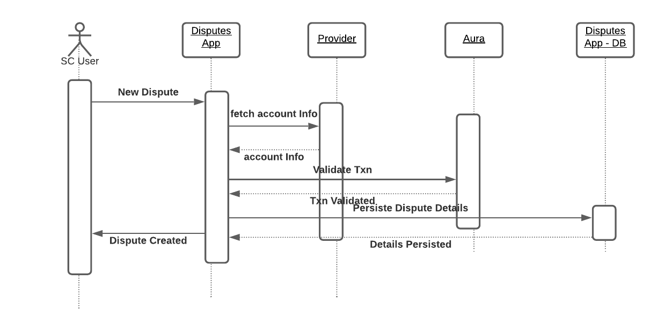

All the providers will have to provide an API endpoint with a response object defined by the Disputes App. These endpoints would be configured in the Disputes App as properties. This may eventually be moved to Crux / Delta.
The details of account info endpoint to be made available by the providers is discussed here.

Dispute Life Cycle APIs

New Dispute Request

API | Report a New Dispute
Method | POST
Endpoint | /disputes/tenants/{tenantId}/accounts/{accountId}/disputes
Request | {  "requestID": "Create_Dispute_Jan_24_2_1",  "provider": "Ruby",  "transactionID": "20220121150618415_594_RetailPayment_Jan_21_21",  "value": {  "amount": 500,  "currency": "USD"  },  "reasonCode": "DISPUTE-101",  "description": "Incorrect amount of Transaction",  "disputeRefNumber": "20211217112617948",  "disputedAt": 1640605144,  "attributes": {}  }
Notes | There would be a fixed set of Reason Codes  ca  This will create a new Dispute record in the Dispute System. Operations team will initiate an Investigation  Dispute Status would be “NEW_DISPUTE” after the API is successful
Validations | - Valid Tenant Id  - requestId may be considered as the Idempotency key  - Transaction Id and Account Id should be valid and the transaction should not have already been disputed for either part or full amount(DisputeAmount<Original trans amount)  - Reason code should be valid  - Other functional Validations like whether a particular kind of transaction based on MCC etc can be disputed or not will be done manually and if necessary the Dispute will be rejected at that stage. (MCC coming in attributes)
Response | HTTP Response Codes -  201 - Created  400 - Bad Request with appropriate Error Object with Error Code / Message  409 - Conflict  {  “id” : “12344354545”,  "requestId": "1607093774000",  "value": {  "amount": 10000,  "currency": "USD"  },  “disputeStatus”: “NEW_DISPUTE”,  “reasonCode”: “DISPUTE-100”  "description": "Incorrect amount of Transaction",  "attributes": {},  “createdAt”: “”,  “updatedAt”: “”  }

Reject a Dispute

API | Reject Dispute
Method | POST
Endpoint | /disputes/tenants/{tenantId}/accounts/{accountId}/disputes/{disputeId}/reject-dispute
Request | {  "requestID": "RejectDispute-Jan5_2",  "reasonCode": "REJECT-100",  "description": "Incorrect amount of Transaction",  "bookTime": 1646218320555,  "attributes": {}  }
Notes | When a new Dispute is raised, the Operations team would conduct some basic investigation and if the request is not found valid, the Dispute is rejected  There would be a fixed set of Reason Codes for Rejection  “REJECT-100” - Time Limit elapsed for Dispute  “REJECT-101” - Invalid Amount  “REJECT-102” - Transaction of of this MCC cannot be disputed  “REJECT-103” - PIN Based transaction cannot be Disputed  “REJECT-104” - Others  In case of “REJECT-104”, description can be used to capture details  This will reject the dispute in the system.  Disputes App would do the following  - Validate Request - Current status of the request should be NEW_DISPUTE  - Create a transition record in the DB  - Update Dispute Status in the Main disputes table  - Invoke Journal Fluent for recovering any provisional/permanent credit provided  - Voucher Code to be used - DISPUTE-REJECT  - Annotate the Aura Transaction to indicate the Dispute Status  - New Status would be DISPUTE_REJECTED and this would be the final state.  Along with this state change, any provisional/permanent credit given upfront to the customer has to be recovered. This is done using the voucher code DISPUTE-REJECT. For accounting entries to be passed, refer Ruby Accounting Summary  Transaction Attributes should include “disputeId” and “disputedTransactionId” (original transaction on which the dispute was raised)
Validations | - Valid Tenant Id -  - Current Status should be NEW_DISPUTE  - requestId may be considered as the Idempotency key  - Transaction Id and Account Id should be valid and the transaction should not have already been Rejected
Response | HTTP Response Codes -  200 - Ok  404 - Not Found - If Tenant Id / account Id /Dispute Id are not valid  409 - Conflict - In Case Dispute already Rejected  {  “id”: "12340937744321"  "value": {  "amount": 10000,  "currency": "USD"  },  “disputeStatus”: “DISPUTE_REJECTED”,  “reasonCode”: “REJECT100”  "description": "Incorrect amount of Transaction",  "attributes": {  “transactionId”: “”,  “bookDate”: “”,  “valueDate”:””  },  “createdAt”: “”  }

Write off a Dispute

API | Write off a Dispute
Method | POST
Endpoint | /disputes/tenants/{tenantId}/accounts/{accountId}/disputes/{disputeId}/write-off-dispute
Request | {  "requestID": "MerchantAcceptDispute_Jan_17_2_1",  "description": "Wrongly debited from customer account",  "value": {  "amount": 100,  "currency": "USD"  },  "bookTime": 1646218320555,  "attributes": {}  }  Value attribute is optional. If this is not supplied in the request, it would be the same as the original dispute amount.
Notes | In cases where the issuer doesn’t want to raise a chargeback with the card network and decides to absorb the disputed amount as an expense, by writing it off and without further pursuing the dispute. This API handles the case when the Issuer decides to write-off the dispute.  Disputes App would do the following  - Validate Request - Current status of the request should be NEW_DISPUTE  - Create a transition record in the DB  - Update Dispute Status in the Main disputes table  - Invoke Journal Fluent for crediting the Fund back to the Customer  - Voucher Code to be used - DISPUTE-WRITEOFF  - Annotate the Aura Transaction to indicate the Dispute Status  - New Status would be WRITE_OFF and this would be the final state.  Along with this state change, any provisional/permanent credit given upfront to the customer has to be recovered. This is also done using the voucher code DISPUTE-WRITEOFF. For accounting entries to be passed, refer Ruby Accounting Summary  Transaction Attributes should include “disputeId” and “disputedTransactionId” (original transaction on which the dispute was raised)
Validations | - Valid Tenant Id / Dispute Id  - Dispute should be in a Valid State - NEW_DISPUTE
Response | HTTP Response Codes -  200 - Ok  404 - Not Found - If Tenant Id /Dispute Id are not valid  409 - Conflict - In Case Dispute already Initiated  {  “disputeId”: "12340937744321",  "value": {  "amount":10000,  "currency": "USD"  },  “disputeStatus”:”WRITE_OFF”,  “reasonCode”: “”  "description": "Dispute written off by issuer",  "attributes": {  “transactionId”: “”,  “bookDate”: “”,  “valueDate”:””  },  “createdAt”: “”  }

Initiate a New Dispute

API | Initiate the Dispute
Method | POST
Endpoint | /disputes/tenants/{tenantId}/accounts/{accountId}/disputes/{disputeId}/initiate-dispute
Request | {  "requestID": "Initiate_Dispute_Jan_18_2_5",  "schemeReferenceId": "23432455435",  "description": "Incorrect amount of Transaction",  "attributes": {}  }  SchemeReferenceID: This could be used to capture the reference number the Scheme may have generated. This would be optional. User may store dispute id itself in this attribute
Notes | Once the initial investigation by the Ops team is done and it is concluded that the dispute is genuine prima facie, the Dispute process is initiated. This involves the following -  - Log a dispute request in the Scheme’s portal - Manually done  - Credit the amount back to the Customer’s account pending final resolution  Disputes App would do the following  - Validate Initiation Request  - Current Status should be NEW_DISPUTE  - Create a transition record in the DB  - Update Dispute Status  - Invoke Journal Fluent for crediting the Fund back to the Customer  - Voucher Code to be used - DISPUTE-INITIATION  - Annotate the Aura Transaction to indicate the Dispute Status  - Status post this API call would be CB_RAISED  In this API call, only the dispute state is updated. No accounting is involved.  Postings Created would be  DR DISPUTED-AMOUNT (System Ledger, Configured via the Product Ledgers)  CR AH Ledger  CR Retail Principal Unbilled and corresponding PL2 Category  Meta Posting of DR DISPUTED-BALANCE Category  Value Date - Original Transaction Date  Transaction Attributes should include “disputeId” and “disputedTransactionId” (original transaction on which the dispute was raised)
Validations | - Valid Tenant Id / Dispute Id  - Dispute should be in a Valid State - NEW_DISPUTE
Response | HTTP Response Codes -  200 - Ok  404 - Not Found - If Tenant Id /Dispute Id are not valid  409 - Conflict - In Case Dispute already Initiated  {  “disputeId”: "12340937744321",  “schemeReferenceId”: “23432455435”,  "value": {  "amount": 10000,  "currency": "USD"  },  “disputeStatus”:”CB_RAISED”,  “reasonCode”: “”  "description": "Dispute Initiated",  "attributes": {  “transactionId”: “”,  “bookDate”: “”,  “valueDate”:””  },  “createdAt”: “”  }

Provide Upfront Provisional/Permanent Credit

API | Provide Upfront Provisional/Permanent Credit
Method | POST
Endpoint | /disputes/tenants/{tenantId}/accounts/{accountId}/disputes/{disputeId}/provide-upfront-credit
Request | {  "requestID": "ProvideUpfrontCredit_Jan_18_2_5",  "description": "Granting provisional credit",  "upfrontCreditIndicator": "PROVISIONAL", // Can be PROVISIONAL or PERMANENT  "value": {  "amount": 100,  "currency": "USD"  },  "bookTime": 1646218320555,  "attributes": {}  }
Notes | For a fraud or a dispute request, the issuer may decide to give a provisional or a permanent credit at any point in the lifecycle after NEW_DISPUTE state and before hitting any terminal state. This can be performed only once. In such a case,  Disputes App would do the following  - Validate that Current Status is NEW_DISPUTE or any non-terminal state after NEW_DISPUTE  - Create a transaction for permanent or provisional credit based on the request  - Voucher code to be used will be  - DISPUTE-PROV-CREDIT for provisional credit  - DISPUTE-PERM-CREDIT for permanent credit  - Update Dispute Record with provisional or permanent credit information  - There will be no change in the status after this API call  For detailed accounting to be performed for specific voucher codes, refer Ruby Accounting Summary
Validations | - Valid Tenant Id / Dispute Id  - Dispute should be in NEW_DISPUTE or any non-terminal state after NEW_DISPUTE
Response | HTTP Response Codes -  200 - Ok  404 - Not Found - If Tenant Id /Dispute Id are not valid  409 - Conflict - In Case credit has already been given  {  “disputeId”: "12340937744321",  “schemeReferenceId”: “23432455435”,  "value": {  "amount": 10000,  "currency": "USD"  },  “disputeStatus”:”NEW_DISPUTE”,  "description": "Granting Provisional Credit",  "upfrontCreditIndicator": "PROVISIONAL", // Can be PROVISIONAL or PERMANENT  “upfrontCreditTransactionID”: “”,  “upfrontCreditTransactionAmount”: “100”,  “bookDate”: “”,  “valueDate”:””,  “createdAt”: “”  }

Raise a Fraud Request

API | Raise a Fraud Request
Method | POST
Endpoint | /disputes/tenants/{tenantId}/accounts/{accountId}/disputes/{disputeId}/raise-fraud
Request | {  "requestID": "Initiate_Dispute_Jan_18_2_5",  "description": "Unauthorized Debit",  "attributes": {}  }
Notes | Once the initial investigation by the Ops team is done and it is concluded that the dispute qualifies as a fraud, a Fraud request is initiated in the system.  Disputes App would do the following  - Validate that Current Status should be NEW_DISPUTE  - Create a transition record in the DB  - Update Dispute Status  - Annotate the Aura Transaction to indicate the Dispute Status  - Status post this API call would be FRAUD_RAISED  In this API call, only the dispute state is updated. No accounting is involved.
Validations | - Valid Tenant Id / Dispute Id  - Dispute should be in a Valid State - NEW_DISPUTE
Response | HTTP Response Codes -  200 - Ok  404 - Not Found - If Tenant Id /Dispute Id are not valid  409 - Conflict - In Case fraud request already raised  {  “disputeId”: "12340937744321",  "value": {  "amount": 10000,  "currency": "USD"  },  “disputeStatus”:”FRAUD_RAISED”,  “reasonCode”: “”  "description": "Fraud Request Initiated",  "attributes": {  “transactionId”: “”,  “bookDate”: “”,  “valueDate”:””  },  “createdAt”: “”  }

Rejection of fraud request

API | Rejection of fraud request
Method | POST
Endpoint | /disputes/tenants/{tenantId}/accounts/{accountId}/disputes/{disputeId}/reject-fraud
Request | {  "requestID": "RejectFraudReq_Jan13_2_1",  "remarks": "Invalid Fraud Request",  "bookDate": 1646218320555,  "attributes": {}  }
Notes | Once the issuer’s internal FRM team completes its investigation of a fraud request and deems it as invalid, the fraud request will be rejected in the system. As part of this API, any provisional/permanent credit given to the customer has to be recovered.  Disputes App would do the following  - Validate current Status - It should be in FRAUD_RAISED status.  - Create a transition record in the DB  - Update Dispute Status in the Main disputes table  - Invoke Journal Fluent to recover the provisional credit made to the customer  - Voucher Code to be used - FRAUD-DISPUTE-REJECT  - Annotate the Aura Transaction to indicate the Dispute Status  - New status would be FRAUD_REJECT  Along with this state change, any provisional/permanent credit given upfront to the customer has to be recovered. This is also done using the voucher code FRAUD-DISPUTE-REJECT. For accounting entries to be passed, refer Ruby Accounting Summary  Transaction Attributes should include “disputeId” and “disputedTransactionId” (original transaction on which the dispute was raised)
Validations | - Valid Tenant Id / Dispute Id  - Dispute should be in a Valid State - FRAUD_RAISED
Response | HTTP Response Codes -  200 - Ok  404 - Not Found - If Tenant Id /Dispute Id are not valid  409 - Conflict - In Case fraud is already rejected  {  “disputeId”: "12340937744321",  "value": {  "amount": 10000,  "currency": "USD"  },  “disputeStatus”:”FRAUD_REJECT”,  “reasonCode”: “”  "description": "Fraud Request Rejected",  "attributes": {  “transactionId”: “”,  “bookDate”: “”,  “valueDate”:””  },  “createdAt”: “”  }

Issuer Acceptance of Fraud

API | Issuer Acceptance of Fraud
Method | POST
Endpoint | /disputes/tenants/{tenantId}/accounts/{accountId}/disputes/{disputeId}/issuer-accept-fraud
Request | {  "requestID": "IssuerAcceptFraud_Jan13_2_2",  "description": "Fraud accepted by issuer",  "value": {  "amount": 50,  "currency": "USD"  },  "bookTime": 1646218320555,  "attributes": {}  }
Notes | After the internal FRM team’s investigation, the issuer may decide to accept that the fraud request is genuine. In this case, the issuer has to bear the expense of providing the customer with the required resolution amount. This API handles the case when the Issuer decides to accept the fraud.  Disputes App would do the following  - Validate Request - Current status of the request should be FRAUD_RAISED  - Create a transition record in the DB  - Update Dispute Status in the Main disputes table  - Invoke Journal Fluent for crediting the Fund to the Customer  - Voucher Code to be used - FRAUD-ISSUER-ACCEPT  - Annotate the Aura Transaction to indicate the Dispute Status  - New Status would be FRAUD_ISSUER_ACCEPT  Along with this state change, any provisional/permanent credit given upfront to the customer has to be recovered. This is also done using the voucher code FRAUD-ISSUER-ACCEPT. For accounting entries to be passed, refer Ruby Accounting Summary  Transaction Attributes should include “disputeId” and “disputedTransactionId” (original transaction on which the dispute was raised)
Validations | - Valid Tenant Id / Dispute Id  - Dispute should be in a Valid State - FRAUD_RAISED
Response | HTTP Response Codes -  200 - Ok  404 - Not Found - If Tenant Id /Dispute Id are not valid  409 - Conflict - In Case Fraud is already accepted  {  “disputeId”: "12340937744321",  "value": {  "amount": 10000,  "currency": "USD"  },  “disputeStatus”:”FRAUD_ISSUER_ACCEPT”,  “reasonCode”: “”  "description": "Fraud Accepted by Customer",  "attributes": {  “transactionId”: “”,  “bookDate”: “”,  “valueDate”:””  },  “createdAt”: “”  }

Merchant Rejection of Dispute

API | Merchant Rejection of Dispute
Method | POST
Endpoint | /disputes/tenants/{tenantId}/accounts/{accountId}/disputes/{disputeId}/cb-reject
Request | {  "requestID": "MerchantRejectDispute_Jan18_2_5",  "remarks": "Rejecting Dispute",  "reasonCode": "MERCHANT-REJECT-100",  "schemeReferenceId": "",  "attributes": {}  }
Notes | The Merchant has rejected the initial Dispute Claim. This would be communicated to the Customer via a notification. Ops team may also liaise with the Customer to get his / her view on the Merchant rejecting the claim. At this stage, there is no impact on account postings. This API is to record the fact that the Merchant has rejected the Dispute Claim.
Validations | - Valid Tenant Id / Dispute Id  - Dispute should be in a Valid State - ​​Should be in CB_RAISED status
Response | HTTP Response Codes -  200 - Ok  404 - Not Found - If Tenant Id /Dispute Id are not valid  409 - Conflict - In Case Dispute is not in the right status for Merchant Rejection  {  “disputeId”: "12340937744321",  “schemeReferenceId”: “23432455435”,  "value": {  "amount": 10000,  "currency": "USD"  },  “disputeStatus”:”CB_REJECTED”,  “reasonCode”: “”  "description": "Dispute Rejected by Merchant",  "attributes": {},  “createdAt”: “”  }

Merchant Acceptance of Dispute

API | Merchant Acceptance of Dispute
Method | POST
Endpoint | /disputes/tenants/{tenantId}/accounts/{accountId}/disputes/{disputeId}/cb-accept-merchant
Request | {  "requestID": "MerchantAcceptDispute_Jan_17_2_1",  "remarks": "Incorrect amount of Transaction",  "value": {  "amount": 100,  "currency": "USD"  },  "bookTime": 1646218320555,  "attributes": {}  }  Value attribute is optional. If this is not supplied in the request, it would be the same as the original dispute amount.
Notes | When the Merchant accepts the dispute, the dispute is resolved in favor of the customer.  Disputes App would do the following  - Validate Initiation Request. It should be in CB_RAISED status  - Create a transition record in the DB  - Update Dispute Status in the Main disputes table  - Invoke Journal Fluent for crediting the Fund back to the Customer  - Voucher Code to be used - DISPUTE-CB-MERCHANT-ACCEPT  - Annotate the Aura Transaction to indicate the Dispute Status  - New status would be CB_MERCHANT_ACCEPT  Along with this state change, any provisional/permanent credit given upfront to the customer has to be recovered. This is also done using the voucher code DISPUTE-CB-MERCHANT-ACCEPT. For accounting entries to be passed, refer Ruby Accounting Summary  Transaction Attributes should include “disputeId” and “disputedTransactionId” (original transaction on which the dispute was raised)
Validations | - Valid Tenant Id / Dispute Id  - Dispute should be in a Valid State - Should be in CB_RAISED status
Response | HTTP Response Codes -  200 - Ok  404 - Not Found - If Tenant Id /Dispute Id are not valid  409 - Conflict - In Case Dispute already Initiated  {  “disputeId”: "12340937744321",  “schemeReferenceId”: “23432455435”,  "value": {  "amount": 10000,  "currency": "USD"  },  “disputeStatus”:”CB_MERCHANT_ACCEPT”,  “reasonCode”: “”  "description": "Dispute Accepted by Merchant",  "attributes": {  “transactionId”: “”,  “bookDate”: “”,  “valueDate”:””  },  “createdAt”: “”  }

Customer Acceptance of Dispute

API | Customer Acceptance of Merchant Rejection
Method | POST
Endpoint | /disputes/tenants/{tenantId}/accounts/{accountId}/disputes/{disputeId}/cb-accept-customer
Request | {  "requestID": "CustomerAcceptDispute_Jan13_2_1",  "remarks": "Customer acceptance of dispute",  "value": {  "amount": 50,  "currency": "USD"  },  "bookTime": 1646218320555,  "attributes": {}  }
Notes | After the Merchant has rejected the Dispute Claim, the same is communicated to the Customer. The Customer could accept this and move on. This API handles the case when the Customer Accepts the Dispute Rejection by the Merchant.  Disputes App would do the following  - Validate current Status - It should be in CB_REJECTED status.  - Create a transition record in the DB  - Update Dispute Status in the Main disputes table  - Invoke Journal Fluent to recover the provisional credit made to the customer  - Voucher Code to be used - DISPUTE-CB-CUSTOMER-ACCEPT  - Annotate the Aura Transaction to indicate the Dispute Status  - New status would be CB_CUSTOMER_ACCEPT  Along with this state change, any provisional/permanent credit given upfront to the customer has to be recovered. This is also done using the voucher code DISPUTE-CB-CUSTOMER-ACCEPT. For accounting entries to be passed, refer Ruby Accounting Summary  Transaction Attributes should include “disputeId” and “disputedTransactionId” (original transaction on which the dispute was raised)
Validations | - Valid Tenant Id / Dispute Id  - Dispute should be in a Valid State
Response | HTTP Response Codes -  200 - Ok  404 - Not Found - If Tenant Id /Dispute Id are not valid  409 - Conflict - In Case Dispute already accepted by customer  {  “disputeId”: "12340937744321",  “schemeReferenceId”: “23432455435”,  "value": {  "amount": 10000,  "currency": "USD"  },  “disputeStatus”:”CB_CUSTOMER_ACCEPT”,  “reasonCode”: “”  "description": "Dispute Accepted by Customer",  "attributes": {  “transactionId”: “”,  “bookDate”: “”,  “valueDate”:””  },  “createdAt”: “”  }

Issuer Acceptance of Chargeback

API | Issuer Acceptance of Chargeback
Method | POST
Endpoint | /disputes/tenants/{tenantId}/accounts/{accountId}/disputes/{disputeId}/cb-accept-issuer
Request | {  "requestID": "IssuerAcceptDispute_Jan13_2_2",  "remarks": "Incorrect amount of Transaction",  "value": {  "amount": 50,  "currency": "USD"  },  "bookTime": 1646218320555,  "attributes": {}  }
Notes | After the Merchant has rejected the Dispute Claim, the same is communicated to the Customer. The Customer could accept this and move on. If the Customer contests the rejection, the Issuer may decide to absorb the charge instead of pursuing the dispute further with the Scheme. This API handles the case when the Issuer decides to accept the charge.  Disputes App would do the following  - Validate Request - Current status of the request should be CB_REJECTED  - Create a transition record in the DB  - Update Dispute Status in the Main disputes table  - Invoke Journal Fluent for crediting the Fund to the Customer  - Voucher Code to be used - DISPUTE-CB-ISSUER-ACCEPT  - Annotate the Aura Transaction to indicate the Dispute Status  - New Status would be CB_ISSUER_ACCEPT  Along with this state change, any provisional/permanent credit given upfront to the customer has to be recovered. This is also done using the voucher code DISPUTE-CB-ISSUER-ACCEPT. For accounting entries to be passed, refer Ruby Accounting Summary  Transaction Attributes should include “disputeId” and “disputedTransactionId” (original transaction on which the dispute was raised)
Validations | - Valid Tenant Id / Dispute Id  - Dispute should be in a Valid State - CB_REJECTED
Response | HTTP Response Codes -  200 - Ok  404 - Not Found - If Tenant Id /Dispute Id are not valid  409 - Conflict - In Case Dispute already accepted by issuer  {  “disputeId”: "12340937744321",  “schemeReferenceId”: “23432455435”,  "value": {  "amount": 10000,  "currency": "USD"  },  “disputeStatus”:”CB_ISSUER_ACCEPT”,  “reasonCode”: “”  "description": "Dispute Accepted by Issuer",  "attributes": {  “transactionId”: “”,  “bookDate”: “”,  “valueDate”:””  },  “createdAt”: “”  }

Reinitiate Dispute - Arbitration Request

API | Reinitiate Dispute - Arbitration Request
Method | POST
Endpoint | /disputes/tenants/{tenantId}/accounts/{accountId}/disputes/{disputeId}/reinitiate-dispute
Request | {  "schemeReferenceId": "23432455435",  "requestID": "ReInitiate_Dispute_Jan_18_2_5",  "value": {  "amount": 100,  "currency": "USD"  },  "reasonCode": "ARB-100",  "description": "Customer Rejected Merchant’s claim. Arbitration initiated",  "attributes": {},  "createdAt": 1638601800000  }  Reason codes:  ARB-100 - Customer rejected Merchant’s explanation  ARB-101 - Others
Notes | After the Merchant has rejected the Dispute Claim, the same is communicated to the Customer. The Customer could accept this and move on. If the Customer contests the rejection, the Issuer may decide to absorb the charge instead of pursuing the dispute further with the Scheme or alternatively, the Issuer may want to initiate Arbitration with the Scheme. This API handles the case when the Issuer decides to initiate Arbitration..  At this stage there is no further accounting impact  Disputes App would do the following  - Validate Initiation Request - Allowed only if the Current Status is CB_REJECTED  - Create a transition record in the DB  - Update Dispute Status in the Main disputes table  - Annotate the Aura Transaction to indicate the Dispute Status  - New Status - ARBITRATION
Validations | - Valid Tenant Id / Dispute Id  - Dispute should be in a Valid State - CB_REJECTED
Response | HTTP Response Codes -  200 - Ok  404 - Not Found - If Tenant Id /Dispute Id are not valid  409 - Conflict - In Case Dispute is not in the relevant status  {  “disputeId”: "12340937744321",  “schemeReferenceId”: “23432455435”,  "value": {  "amount": 10000,  "currency": "USD"  },  “disputeStatus”:”ARBITRATION”,  “reasonCode”: “”  "description": "Customer Rejected Merchant’s claim. Arbitration initiated",  "attributes": {},  “createdAt”: “”  }

Arbitration in Favor of Customer

API | Merchant Acceptance of Arbitration Decision in Favor of Customer
Method | POST
Endpoint | /disputes/tenants/{tenantId}/accounts/{accountId}/disputes/{disputeId}/arb-accept-merchant
Request | {  "schemeReferenceId": "23432455435",  "requestID": "Merchant_Accept_ARB_Jan_18_2_1",  "description": "Merchant Accepts ARB",  "value": {  "amount": 50,  "currency": "USD"  },  "bookDate": 1646218320555,  "attributes": {}  }
Notes | Arbitration proceedings may be initiated by the Issuer when the initial Dispute claim is rejected by the Merchant and the Customer has rejected the Merchant’s explanation. Arbitration may end up in favor of the Customer and the Merchant has accepted the final outcome of Arbitration.  This API caters to this scenario  Disputes App would do the following  - Validate current Status - It should be in ARBITRATION status.  - Create a transition record in the DB  - Update Dispute Status in the Main disputes table  - Invoke Journal Fluent for crediting the Fund to the Customer  - Voucher Code to be used - DISPUTE-ARB-MERCHANT-ACCEPT  - Annotate the Aura Transaction to indicate the Dispute Status  - New Status - ARB_MERCHANT_ACCEPT  Along with this state change, any provisional/permanent credit given upfront to the customer has to be recovered. This is also done using the voucher code DISPUTE-ARB-MERCHANT-ACCEPT. For accounting entries to be passed, refer Ruby Accounting Summary  Transaction Attributes should include “disputeId” and “disputedTransactionId” (original transaction on which the dispute was raised)
Validations | - Valid Tenant Id / Dispute Id -  - Dispute should be in a Valid State - Status should be ARBITRATION
Response | HTTP Response Codes -  200 - Ok  404 - Not Found - If Tenant Id /Dispute Id are not valid  409 - Conflict - In Case Dispute already Initiated  {  “disputeId”: "12340937744321",  “schemeReferenceId”: “23432455435”,  "value": {  "amount": 10000,  "currency": "USD"  },  “disputeStatus”: “ARB_MERCHANT_ACCEPT”,  “reasonCode”: “”  "description": "Arbitration decision Accepted by Merchant",  "attributes": {  “transactionId”: “”,  “bookDate”: “”,  “valueDate”:””  },  “createdAt”: “”  }

Arbitration Reject - Ruled in Merchant’s favor

API | Arbitration Rejection of Dispute
Method | POST
Endpoint | /disputes/tenants/{tenantId}/accounts/{accountId}/disputes/{disputeId}/arb-reject
Request | {  "requestID": "Arb_Customer_reject_Jan_18_2_1",  “reasonCode”:”ARB-REJECT-100”,  “remarks” : “”,  “attributes”:{}  }
Notes | Once the arbitration has been ruled in favor of the merchant, there can be only two possible outcomes. Either the issuer has to accept the disputed amount as expense or the customer has to accept the loss. This API is to record the fact that the arbitration was ruled in favor of the merchant.
Validations | - Valid Tenant Id / Dispute Id  - Dispute should be in a Valid State - ​​Should be in ARBITRATION status
Response | HTTP Response Codes -  200 - Ok  404 - Not Found - If Tenant Id /Dispute Id are not valid  409 - Conflict - In Case Dispute is not in the right status for Arbitration Rejection  {  “Id”: “3355464w32545”,  “disputeId”: "12340937744321",  “schemeReferenceId”: “23432455435”,  "value": {  "amount": 10000,  "currency": "USD"  },  “disputeStatus”:”ARB_REJECT”,  “reasonCode”: “”  "description": "Dispute ruled in favor of the Merchant",  "attributes": {},  “createdAt”: “”  }

Customer Acceptance of loss - Post Arbitration

API | Customer Acceptance of Arbitration Decision in Favor of Merchant
Method | POST
Endpoint | /disputes/tenants/{tenantId}/accounts/{accountId}/disputes/{disputeId}/arb-accept-customer
Request | {  "schemeReferenceId": "23432455435",  "requestID": "ReInitiate_Dispute_Jan_18_2_3",  "description": "Customer accepts arbitration loss",  "bookTime": 1646218320555,  "attributes": {}  }
Notes | Arbitration proceedings may be initiated by the Issuer when the initial Dispute claim is rejected by the Merchant and the Customer has rejected the Merchant’s explanation. Arbitration may end up in favor of the Merchant and the Customer has accepted the final outcome of Arbitration.  This API caters to this scenario  Disputes App would do the following  - Validate current Status - It should be in ARB_REJECT status.  - Create a transition record in the DB  - Update Dispute Status in the Main disputes table  - Invoke Journal Fluent to recover the provisional credit made to the customer  - Voucher Code to be used - DISPUTE-ARB-CUSTOMER-ACCEPT  - Annotate the Aura Transaction to indicate the Dispute Status  - New Status - ARB_CUSTOMER_ACCEPT  Along with this state change, any provisional/permanent credit given upfront to the customer has to be recovered. This is also done using the voucher code DISPUTE-ARB-CUSTOMER-ACCEPT. For accounting entries to be passed, refer Ruby Accounting Summary  Transaction Attributes should include “disputeId” and “disputedTransactionId” (original transaction on which the dispute was raised)
Validations | - Valid Tenant Id / Dispute Id -  - Dispute should be in a Valid State - Status should be ARB_REJECT
Response | HTTP Response Codes -  200 - Ok  404 - Not Found - If Tenant Id /Dispute Id are not valid  409 - Conflict - In Case Dispute already accepted by customer  {  “disputeId”: "12340937744321",  “schemeReferenceId”: “23432455435”,  "value": {  "amount": 10000,  "currency": "USD"  },  “disputeStatus”: “ARB_CUSTOMER_ACCEPT”,  “reasonCode”: “”  "description": "Arbitration decision Accepted by Customer",  "attributes": {  “transactionId”: “”,  “bookDate”: “”,  “valueDate”:””  },  “createdAt”: “”  }

Issuer Acceptance of Cost - Post Arbitration

API | Issuer Acceptance of Charge post Arbitration
Method | POST
Endpoint | /disputes/tenants/{tenantId}/accounts/{accountId}/disputes/{disputeId}/arb-accept-issuer
Request | {  "schemeReferenceId": "23432455435",  "requestID": "Issuer_Accept_ARB_Jan_18_2_2",  "description": "Customer Rejected Merchant’s claim. Arbitration initiated",  "value": {  "amount": 50,  "currency": "USD"  },  "bookTime": 1646218320555,  "attributes": {}  }
Notes | Arbitration proceedings may be initiated by the Issuer when the initial Dispute claim is rejected by the Merchant and the Customer has rejected the Merchant’s explanation. Arbitration may end up in favor of the Customer / Merchant. It may be possible that the Arbitration decision is not accepted by the losing party. In such cases, the Issuer may take the charge to avoid further proceedings.  This API caters to this scenario  Disputes App would do the following  - Validate current Status - It should be in ARB_REJECT status.  - Create a transition record in the DB  - Update Dispute Status in the Main disputes table  - Invoke Journal Fluent for crediting the Fund back to the Customer  - Voucher Code to be used - DISPUTE-ARB-ISSUER-ACCEPT  - Annotate the Aura Transaction to indicate the Dispute Status  - New Status - ARB_ISSUER_ACCEPT  Along with this state change, any provisional/permanent credit given upfront to the customer has to be recovered. This is also done using the voucher code DISPUTE-ARB-ISSUER-ACCEPT. For accounting entries to be passed, refer Ruby Accounting Summary  Transaction Attributes should include “disputeId” and “disputedTransactionId” (original transaction on which the dispute was raised)
Validations | - Valid Tenant Id / Dispute Id -  - Dispute should be in a Valid State - Status should be ARB_REJECT
Response | HTTP Response Codes -  200 - Ok  404 - Not Found - If Tenant Id /Dispute Id are not valid  409 - Conflict - In Case Dispute already accepted by Issuer  {  “disputeId”: "12340937744321",  “schemeReferenceId”: “23432455435”,  "value": {  "amount": 10000,  "currency": "USD"  },  “disputeStatus”: “ARB_ISSUER_ACCEPT”,  “reasonCode”: “”  "description": "Arbitration decision Accepted by Issuer",  "attributes": {  “transactionId”: “”,  “bookDate”: “”,  “valueDate”:””  },  “createdAt”: “”  }

Inquiry APIs

Fetch Dispute Detains By Dispute Id

API | Fetch Details of a Dispute by Dispute Id
Method | GET
Endpoint | /disputes/tenants/{tenantId}/disputes/{disputeId}
Request
Notes | Retrieve the full details of a Dispute along with the state transition information for a specific Dispute.
Validations | - Valid Tenant Id / Dispute Id -  - Dispute should be in a Valid State
Response Codes | HTTP Response Codes -  200 - Ok  404 - Not Found - If Tenant Id /Dispute Id are not valid
Response Body | {  "id":"1232453535",  "tenantId":1234567,  "disputeRefNo":"433445",  "accountId":"1232424234",  "accountHolderId":"23243242",  "originalTransactionId":"2132424244",  "disputedValue":{  "amount":"2000",  "currency":"USD"  },  "upfrontCreditIndicator":"NONE", //Can be PROVISIONAL, PERMANENT, NONE  "upfrontCreditTransactionID":"",  "upfrontCreditTransactionAmt":"",  "disputeResolutionAmt":"",  "disputeReasonCode":"DISPUTE-100",  "disputeDate":1635257265,  "disputeLastTransitionDate":1683721265,  "disputeStatus":"CB_RAISED",  "attributes":{  "dispute.mcc":"1234344",  "dispute.mid":"324",  "dispute.tid":"324242"  },  "disputeTransitions":[  {  "id":"234243434",  "requestId":"342434534",  "externalId":"12423dsr4234",  "disputeStatus":"NEW_DISPUTE",  "reasonCode":"DISPUTE-100",  "remarks":"Unknown Transaction",  "accountingTransactionId":"",  "attributes":{  "dispute.mcc":"1234344",  "dispute.mid":"324",  "dispute.tid":"324242"  },  "createdAt":1603721265,  "updatedAt":1603721265  },  {  "id":"54544546",  "requestId":"54556576",  "externalId":"124335464",  "disputeStatus":"CB_RAISED",  "reasonCode":"DISPUTE-101",  "remarks":"Invalid Amount",  "accountingTransactionId":"",  "attributes":{  },  "createdAt":1666793265,  "updatedAt":1666793265  }  ]  }

Generic Disputes Inquiry

API | Generic Disputes Inquiry
Method | GET
Endpoint | /disputes/tenants/{tenantId}/disputes?accountId=232323&accountHolderId=123232432434&mcc=1232323&mid=12323&tid=12323&fromDisputeDate=22102021&toDisputeDate=251020201&fromResolutionDate=10112021&toResolutionDate=15112021&status=CB_ACCEPT_MERCHANT&pageSize=10&pageNumber=1&sortKey=accountID&sortOrder=DESC
Query Params | accountId  accountHolderId  mcc  miid  tid  fromDisputeDate  toDisputeDate  fromResolutionDate  toResolutionDate  status  pageSize  pageNumber  sortKey  sortOrder  All these parameters would be optional
Notes | Retrieve the full details of a Dispute along with the state transition information matching certain criteria
Validations | - Valid Tenant Id / Dispute Id -  - Dispute should be in a Valid State
Response Codes | HTTP Response Codes -  200 - Ok  404 - Not Found - If Tenant Id /Dispute Id are not valid
Response Body | [  {  "id":"1232453535",  "tenantId":1234567,  "disputeRefNo":"433445",  "accountId":"1232424234",  "accountHolderId":"23243242",  "originalTransactionId":"2132424244",  "disputedValue":{  "amount":"2000",  "currency":"USD"  },  "upfrontCreditIndicator":"NONE", //Can be PROVISIONAL,PERMANENT,NONE  "upfrontCreditTransactionID":"",  "upfrontCreditTransactionAmt":"",  "disputeResolutionAmt":"",  "disputeReasonCode":"DISPUTE-100",  "disputeDate":1635257265,  "disputeLastTransitionDate":1683721265,  "disputeStatus":"CB_RAISED",  "attributes":{  "dispute.mcc":"1234344",  "dispute.mid":"324",  "dispute.tid":"324242"  },  "disputeTransitions":[  {  "id":"234243434",  "requestId":"342434534",  "externalId":"12423dsr4234",  "disputeStatus":"NEW_DISPUTE",  "reasonCode":"DISPUTE-100",  "remarks":"Unknown Transaction",  "accountingTransactionId":"",  "attributes":{  "dispute.mcc":"1234344",  "dispute.mid":"324",  "dispute.tid":"324242"  },  "createdAt":1603721265,  "updatedAt":1603721265  },  {  "id":"54544546",  "requestId":"54556576",  "externalId":"124335464",  "disputeStatus":"CB_RAISED",  "reasonCode":"DISPUTE-101",  "remarks":"Invalid Amount",  "accountingTransactionId":"",  "attributes":{  },  "createdAt":1666793265,  "updatedAt":1666793265  }  ]  }  ]

Account Info Endpoint

API | Account Info
Method | GET
Endpoint | /ruby/tenants/{tenantId}/accounts/{accountId}
Query Params | NA
Notes | Each Provider provides this endpoint. This example is in the context of Ruby. Similar endpoints would be provided by Sapphire and Pearl as the Debit and Prepaid card transactions would have to manage disputes as well.
Validations | - Valid Tenant Id / Account Id -  - If this API returns 404, the Dispute Creation API also needs to return same error as it would be unable to create the Dispute
Response Codes | HTTP Response Codes -  200 - Ok  404 - Not Found - If Tenant Id /Dispute Id are not valid
Response Body | {  "accountId": "d8983514-f72c-4048-a944-507d4ee377c8",  "accountHolderId": "71ed52c0-135e-48cb-b254-b1dafed13306",  "accountName": "Credit card Account for Domestic Travel",  "coaId": 1670706735183594041,  "productId": 6953694978516545727,  "ledgerId": 8884232166375125373,  "attribs":  {  "key1": "value1",  "key2": "value2"  }  }

Limitations

- Disputes can be for a partial amount
- Only One Dispute can be raised per transaction
- Multiple Partial Disputes cannot be raised
- Disputes relate to customer initiated Card transactions only. Doesn’t cover issuer initiated transactions.
- Fee / Taxes / Interest pertaining to disputed transactions need to be handled manually as adjustments

Configurations

Tenant Level Configurations

Voucher Codes

- DISPUTE-INITIATE
- DISPUTE-WRITEOFF
- DISPUTE-REJECT
- DISPUTE-PROV-CREDIT
- DISPUTE-PERM-CREDIT
- FRAUD-DISPUTE-REJECT
- FRAUD-ISSUER-ACCEPT
- DISPUTE-CB-MERCHANT-ACCEPT
- DISPUTE-CB-CUSTOMER-ACCEPT
- DISPUTE-CB-ISSUER-ACCEPT
- DISPUTE-ARB-MERCHANT-ACCEPT
- DISPUTE-ARB-CUSTOMER-ACCEPT
- DISPUTE-ARB-ISSUER-ACCEPT

Ruby Level Configurations

Posting Category

Posting Category DISPUTES should be created by all the Account Providers for the Ultimate Parent CoA Node of AH Ledger. For instance in Ruby, this should be associated with Revolving-Credit CoA Node.

Available Balance Check

Currently, Available balance is calculated as Credit Limit - Current Balance - Hold. This may have to be modified to Credit Limit - Current Balance - Hold - Disputed Balance based on the Bank’s need. This is currently enforced via a T-Policy, which is applicable to the whole of Ruby. This policy would have to be modified based on the Tenant’s (Bank’s) need.

Product Ledgers

Certain System ledgers need to be configured to post the adjustments at various stages of the Dispute Life cycle. The following Ledgers need to be configured in the Product Ledgers Attachment. The system ledgers involved in various dispute accounting are
- Network specific Dispute Receivable Ledger - Asset Ledger
- Network specific Chargeback Payable Ledger - Liability Ledger
- Chargeback Expense Ledger - Expense Ledger

"liabilityLedgers":[
{
"ledgerCode":"ledger://code/DISPAMT001",
"voucherCodeMappingArray":[
{
"voucherCode":"*",
"component":"DISPUTED-AMOUNT"
}
]
},
"expenseLedgers":[
{
"ledgerCode":"ledger://code/DISPEXP001",
"voucherCodeMappingArray":[
{
"voucherCode":"*",
"component":"ISSUER-DISPUTE-EXPENSET"
}
]
}

If the configuration for the specific Voucher Code is present, that takes precedence over the wildcard voucher code

PPTS

Accounting entries corresponding to various voucher codes has been described in the sheet Ruby Accounting Summary

Voucher Code | PPTS
DISPUTE-INITIATE | DR DISPUTED-AMOUNT (System Ledger, Configured via the Product Ledgers)  CR AH Ledger  CR Retail Principal Unbilled and corresponding PL2 Category  Meta Posting of DR DISPUTED-BALANCE Category  Value / Book Date - Original Transaction Date
DISPUTE-WRITEOFF | DR DISPUTED-AMOUNT (Expense type System Ledger, mapped to the Product)  CR DISPUTED-AMOUNT AH Ledger  Value / Book Date - Resolution Date
DISPUTE-CB-MERCHANT-ACCEPT | DR NETWORK-PAYABLE  CR DISPUTED-AMOUNT (System Ledger, Configured via the Product Ledgers)  CR AH Ledger - Meta Posting  Meta Posting of CR DISPUTED-BALANCE Category  Value / Book Date - Resolution Date
DISPUTE-CB-CUSTOMER-ACCEPT | DR AH Ledger -  Attribution 100% to Retail Principal Unbilled and corresponding PC on PL2  Meta Posting of CR DISPUTED-BALANCE Category  CR DISPUTED-AMOUNT (System Ledger, Configured via the Product Ledgers)  Value / Book Date - Original Transaction Date
DISPUTE-CB-ISSUER-ACCEPT | DR DISPUTED-AMOUNT (Expense type System Ledger, mapped to the Product)  CR AH Ledger - Meta Posting  Meta Posting of CR DISPUTED-BALANCE Category  CR DISPUTED-AMOUNT (System Ledger, Configured via the Product Ledgers)  Value / Book Date - Resolution Date
DISPUTE-ARB-MERCHANT-ACCEPT | DR NETWORK-PAYABLE  CR DISPUTED-AMOUNT (System Ledger, Configured via the Product Ledgers)  CR AH Ledger - Meta Posting  Meta Posting of CR DISPUTED-BALANCE Category  Value / Book Date - Resolution Date
DISPUTE-ARB-CUSTOMER-ACCEPT | DR AH Ledger -  Attribution 100% to Retail Principal Unbilled and corresponding PC on PL2  Meta Posting of CR DISPUTED-BALANCE Category  CR DISPUTED-AMOUNT (System Ledger, Configured via the Product Ledgers)  Value / Book Date - Original Transaction Date
DISPUTE-ARB-ISSUER-ACCEPT | DR DISPUTED-AMOUNT (Expense type System Ledger, mapped to the Product)  CR AH Ledger - Meta Posting  Meta Posting of CR DISPUTED-BALANCE Category  CR DISPUTED-AMOUNT (System Ledger, Configured via the Product Ledgers)  Value / Book Date - Resolution Date

Support Center Use Cases

New Dispute Reporting

Customer may report a Dispute by calling the Support Center. The support agent would search for the Customer based on the name and authenticate the caller. Once authentication is done, the agent is presented with an overview of the Customer along with his accounts and other information.

Agent would click the relevant account and navigate to the relevant transaction on the transactions panel. He / She would then select the “Dispute” action against the transaction. This would then navigate the agent to a page to capture the details of the request which would then be submitted to create a new Dispute Request.

Manage Dispute

A Dispute inquiry feature to be provided. Agent should be able to inquire disputes based on the following search parameters

- accountId
- accountHolderId
- Disputereference
- mcc
- mid
- tid
- disputeStatus
- Dispute Date Range
- Dispute Resolution Date Range

The Agent should be able to enter any / all of the above and be able to search. We should allow wildcards in the search parameters.

Search results should be paginated with the ability to configure the records be page.

Each result should have an Actions button which will reveal all the allowed actions for the record based on its status.

Agent would select the needed action to be navigated to a page to capture the details of the action.

Use cases for Future

Task Queue Management
At various stages of the Dispute Life cycle, Support / Operations agents may have to investigate and track the dispute. These activities may be assigned to specific individuals / groups to act on. They would be able to comment, escalate, action the task as needed.

In order to enable this, it may be needed to design a Task Queue management feature and integrate Disputes into it. This will need to be taken up in a future phase.

Disputes Dashboard
Disputes Dashboard to be made available in the Ops Center to monitor overall Metrics. We could consider the following Metrics for display

- Total Open Disputes
  - Count
  - Value
- Total Open Disputes By Status
  - Count
  - Value
- Top MCC with Disputes
  - Count
  - Value
- Histogram of New Disputes
  - By time slices
- Ageing Analysis Chart of Open Disputes

Atropos Events
Every step in the life cycle of the Dispute would create a corresponding Atropos Event. This event could be leveraged to send Notifications to the customer or to realize any other use case as needed.

Event Data would contain the same dispute object in the “data” element of the event as in the response to the fetch dispute by id API

Following event names are emitted

topic | _tenant_140793_DISPUTE
name | Format - DISPUTE_<event_name>_UPDATED  One of the following  DISPUTE_NEW_DISPUTE_UPDATED  DISPUTE_WRITE_OFF_UPDATED  DISPUTE_DISPUTE_REJECTED_UPDATED  DISPUTE_UPFRONT_CREDIT_UPDATED  DISPUTE_FRAUD_RAISED_UPDATED  DISPUTE_FRAUD_REJECTED_UPDATED  DISPUTE_FRAUD_ISSUER_ACCEPT_UPDATED  DISPUTE_CB_RAISED_UPDATED  DISPUTE_CB_MERCHANT_ACCEPT_UPDATED  DISPUTE_CB_REJECTED_UPDATED  DISPUTE_CB_ISSUER_ACCEPT_UPDATED  DISPUTE_CB_CUSTOMER_ACCEPT_UPDATED  DISPUTE_ARBITRATION_UPDATED  DISPUTE_ARB_CUSTOMER_ACCEPT_UPDATED  DISPUTE_ARB_MERCHANT_ACCEPT_UPDATED  DISPUTE_ARB_ISSUER_ACCEPT_UPDATED
data | {  "id":"1232453535",  "tenantId":1234567,  "disputeRefNo":"433445",  "accountId":"1232424234",  "accountHolderId":"23243242",  "originalTransactionId":"2132424244",  "disputedValue":{  "amount":"2000",  "currency":"USD"  },  "upfrontCreditIndicator":"NONE", //Can be PROVISIONAL, PERMANENT, NONE  "upfrontCreditTransactionID":"",  "upfrontCreditTransactionAmt":"",  "disputeResolutionAmt":"",  "disputeReasonCode":"DISPUTE-100",  “disputeDescription”:"description in the request payload",  "disputeDate":1635257265,  "disputeLastTransitionDate":1683721265,  "disputeStatus":"CB_RAISED",  "schemeReferenceID":"",  "attributes":{  "dispute.mcc":"1234344",  "dispute.mid":"324",  "dispute.tid":"324242"  },  "disputeTransitions":[  {  "id":"234243434",  "requestId":"342434534",  "externalId":"12423dsr4234",  "disputeStatus":"NEW_DISPUTE",  "reasonCode":"DISPUTE-100",  "remarks":"Unknown Transaction",  "attributes":{  "dispute.mcc":"1234344",  "dispute.mid":"324",  "Dispute.tid":"324242",  "transactionID":"",  },  "createdAt":1603721265,  "updatedAt":1603721265  },  {  "id":"54544546",  "requestId":"54556576",  "externalId":"124335464",  "disputeStatus":"CB_RAISED",  "reasonCode":"DISPUTE-101",  "remarks":"Invalid Amount",  "Attributes":{  "transactionID":"SampleTransactionID"  },  "createdAt":1666793265,  "updatedAt":1666793265  }  ]  }

Preferences
Dispute can be raised only on a network transaction. Voucher codes available for network transactions:
1. CARD_CASH_CLEARANCE_AGAINST_HOLD
2. CARD_PURCHASE_CLEARANCE_AGAINST_HOLD
3. CARD_CASH_DEBIT_ADJUSTMENTS
4. CARD_PURCHASE_DEBIT_ADJUSTMENTS
5. CARD_DEBIT_ADJUSTMENTS

